CitiSense: A Mobile-Based Barangay Complaint and Recommendation System

A Software Engineering 1 Project presented to the faculty of
Department of Computing and Informatics
of the City College of Calamba
Calamba City, Laguna

BACHELOR OF SCIENCE IN COMPUTER SCIENCE

COPRE, RALPH LAURENCE D.
CREDO, ALYSSA JOY M.
LOPEZ, TIMOTHY JOHN
II- CS1
September 2026

Chapter 3

METHODOLOGY
This chapter presents the systematic procedures employed in the design, development, and evaluation of the CitiSense system. It establishes the research locale, the population and participants of the study, the sampling technique, and the data collection instruments, together with the quantitative and qualitative data analysis methods used to treat the gathered information. It likewise details the software development methodology, the system modeling artifacts (use case diagram, operational flowchart, context diagram, and process decomposition data flow diagram), the development tools and technologies, and the phased software development schedule. Ethical considerations governing the conduct of the study are also presented.
Research Design
This study employs a mixed-methods research design combined with a developmental approach grounded in the Agile methodology. The quantitative component uses structured survey instruments based on the ISO/IEC 25010:2023 software product quality model to evaluate the system across all eight quality characteristics, complemented by standard machine learning metrics accuracy, precision, recall, and F1-score that validate the on-device sentiment classifier. The qualitative component captures user experiences, opinions, and suggestions through open-ended questionnaire items and semi-structured interviews, which are interpreted using thematic analysis. The developmental dimension of the design is realized through iterative sprint cycles that continuously integrate community-stakeholder feedback into the design, development, and refinement of the system.
To ensure modularity and zero-dependency offline development, the Data Layer strictly implements the Repository design pattern. An abstract interface, AppRepository, defines the contract for all data operations, including user authentication, complaint submission, status transitions (Pending → In Review → Resolved/Rejected), proof-image uploads, and audit logging. Two interchangeable implementations are provided: (1) MockRepository, a local-first repository backed by shared_preferences that operates completely offline without internet or API keys, pre-populated with demo accounts for all three roles and seed complaints across Calamba City; and (2) a managed cloud backend (Supabase or Firebase) providing Auth, Database, and Storage for real-time synchronization and multi-device deployment. The Provider/ChangeNotifier AppState coordinates session state and triggers on-device sentiment analysis. External route guidance is delegated to a Navigation Provider (OSRM public API with Google Maps deep-link fallback), whose role is formalized in the system architecture and process decomposition diagrams presented in this chapter.
Application state management is implemented using the ChangeNotifier and Provider pattern. The central AppState class coordinates user session state, manages active feedback collections, triggers on-device sentiment analysis, and dispatches UI notifications across all active screens, ensuring seamless UI updates without tight coupling to the data persistence layer.

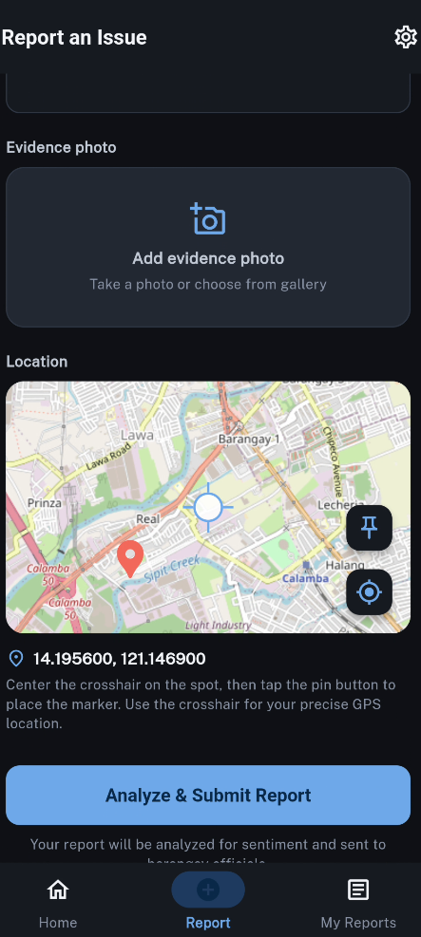
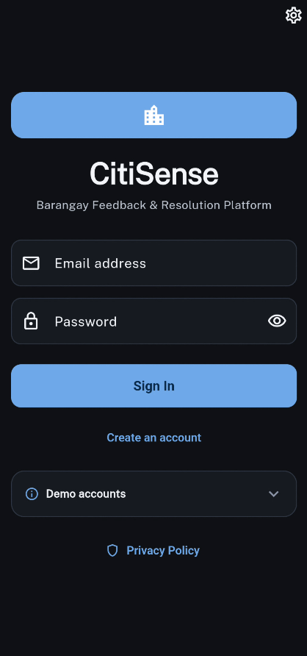
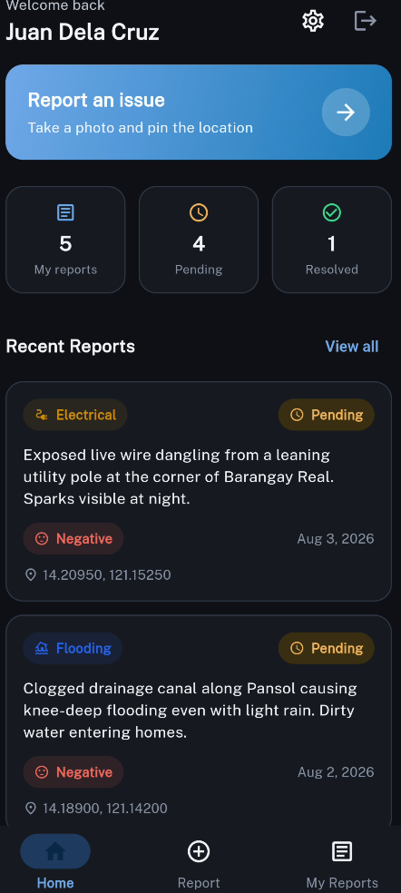
Figure 3. Illustrates the integration of user interface, data processing, and reporting modules to support community feedback management.
Research Locale
The empirical evaluation of CitiSense is situated in Barangay Halang, Calamba City, Laguna. Barangay Halang is a densely populated, rapidly urbanizing community encompassing major residential subdivisions, commercial establishments, and institutional centers. The barangay hall serves as the central administrative hub for public service delivery.
Barangay Halang was specifically selected due to its heavy reliance on traditional, paper-based feedback mechanisms, such as physical suggestion boxes, paper logbooks, walk-in inquiries, and informal social media messages. These manual modalities frequently suffer from lost records, unorganized tracking, and delayed resolution times, making Barangay Halang an ideal testbed for evaluating the practical benefits of CitiSense.
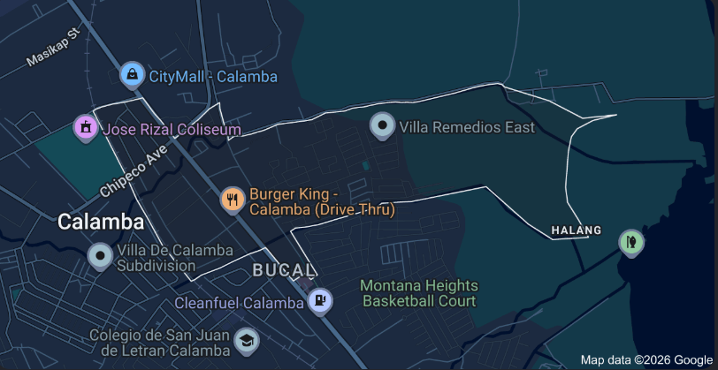
Figure 3.1. Barangay Halang, Calamba City Map.
Population and Participants of the Study
The target population comprises residents and barangay personnel residing or serving within Barangay Halang, Calamba City. Participants are organized into two distinct user groups to evaluate both sides of the civic governance platform.
Table 1. Population and Participants
Group | Role in the Study | Functions in CitiSense | Selection Criteria
Residents | Primary users | Submit feedback, complaints, and suggestions via the mobile app; view sentiment tags and track resolution progress | Ability to use mobile technology; residence in Barangay Halang; willingness to participate
Barangay Officials | Administrators | Access administrative interface to review, analyze, acknowledge, resolve (with proof photo), or reject complaints | Direct involvement in barangay governance; official position in Barangay Halang; willingness to engage
Table 1 emphasizes how CitiSense balances citizen input with official oversight, ensuring that both user groups contribute to the continuous improvement of barangay governance.
Sampling Technique
The study applies a purposive sampling technique to select respondents. Purposive sampling is appropriate because system evaluation necessitates participants who possess Android mobile devices, have experience filing community concerns or managing public records, and represent the actual demographic profile of barangay governance stakeholders.
Inclusion Criteria
Participants must fulfill the following criteria: (1) Must be a bona fide resident or appointed/elected official of Barangay Halang, Calamba City; (2) Must own or have regular access to an Android smartphone running Android 8.0 or higher capable of executing the Flutter APK; and (3) Must be willing to participate in usability trials, test complaint submissions, and complete evaluation questionnaires.
Exclusion Criteria
Individuals will be excluded if they: (1) Do not reside or work within Barangay Halang; (2) Do not possess an Android-compatible mobile device; or (3) Are unable or unwilling to complete user acceptance testing and survey instruments.
Instruments of the Study
The research employs three primary data collection instruments to capture technical performance and user experience:
(1) Software Quality Evaluation Questionnaire: A structured survey formulated around the ISO/IEC 25010:2023 software product quality model, evaluating Functional Suitability, Performance Efficiency, Compatibility, Usability, Reliability, Security, Maintainability, and Portability.
(2) CitiSense Mobile Application Logging: The application instrument itself logs automated telemetry, including NLP classification latency, sentiment output distributions, and status transition timestamps.
(3) Semi-Structured Qualitative Interview Guide: A qualitative interview guide administered to barangay officials and selected residents to capture insights into operational adoption, workflow improvements, and usability bottlenecks.
Data Analysis
Quantitative survey responses are measured using a 4-point Likert scale. A 4-point scale was deliberately selected over a 5-point scale to eliminate the neutral midpoint option, thereby compelling respondents to take a definitive stance regarding system quality and minimizing central tendency distortion.
Table 2. 4 Point Likert Scale
Scale | Range | Verbal Interpretation
4 | 3.50 – 4.00 | Strongly Agree
3 | 2.50 – 3.49 | Agree
2 | 1.50 – 2.49 | Disagree
1 | 1.00 – 1.49 | Strongly Disagree
Table 2 presents the 4-point Likert scale used for evaluating the system, striking the right balance between clarity, reliability, and ease of interpretation.
Weighted Mean Computation
Evaluation ratings across each ISO/IEC 25010 characteristic are quantified by computing the weighted mean:
Weighted Mean = ∑(w_i · x_i) / ∑w_i
where x_i represents the Likert rating value (4, 3, 2, or 1), w_i denotes the response frequency assigned to that rating, and ∑w_i represents the aggregate number of respondent evaluations.
For example, assuming 100 respondents evaluate the usability of CitiSense with ratings of 25 Strongly Agree (4), 45 Agree (3), 20 Disagree (2), and 10 Strongly Disagree (1), the computation yields: [(25×4) + (45×3) + (20×2) + (10×1)] / 100 = 285 / 100 = 2.85. Referring to Table 2, 2.85 corresponds to the verbal interpretation of 'Agree', indicating positive usability acceptance.
Machine Learning Performance Metrics
To rigorously evaluate the Multinomial Naive Bayes classification algorithm, standard machine learning metrics are computed across positive, negative, and neutral classes using a held-out test dataset:
Accuracy = (TP + TN) / (TP + TN + FP + FN)
Precision = TP / (TP + FP)
Recall = TP / (TP + FN)
F1-Score = 2 · (Precision · Recall) / (Precision + Recall)
Qualitative Data Analysis & Integration of Results
Qualitative narrative feedback gathered through open-ended questionnaire items and interviews is analyzed following the thematic analysis framework established by Braun and Clarke. Qualitative codes are iteratively derived, grouped into categories, and synthesized into overarching themes regarding system utility and governance transparency.
Through method triangulation, quantitative Likert ratings and machine learning accuracy scores are integrated with qualitative thematic findings, establishing a multi-dimensional appraisal of CitiSense's technical validity and civic efficacy.
Software Development Methodology
The engineering of CitiSense follows the Agile Software Development Methodology. Agile is well-suited for civic mobile application development because it breaks project execution into iterative, manageable sprint cycles, enabling rapid adaptation to feedback from community stakeholders and facilitating continuous integration between mobile UI development and machine learning pipelines. Figure 3.2 visualizes this cycle, and every phase described in this section is anchored to the corresponding artifact shown in the figures that follow.
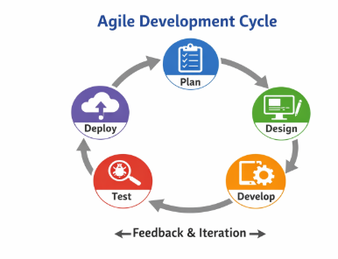
Figure 3.2. Agile Development Cycle. The iterative process cycles through the Plan, Design, Develop, Test, and Deploy stages.
System Overview
Development Tools and Technologies
The CitiSense application is implemented with the Flutter framework using the Dart programming language, and is built for Android devices. Flutter's widget-based approach directly reflects the layered design described in the system architecture earlier in this chapter: the three role-based user interfaces, the shared application state managed through Provider and ChangeNotifier, and the interchangeable data layer placed behind a repository interface. Because the sentiment classification engine runs on the device, the application remains fully functional even without an internet connection.
The principal tools and technologies used in the project are summarized in Table 3:
Table 3. Development Tools and Technologies
Tool / Technology | Purpose in CitiSense
Flutter and Dart | Cross-platform application framework and programming language used for the Android client.
Provider and ChangeNotifier | State management that connects the user interface to the shared application state.
flutter_map with OSRM and Google Maps | On-device route guidance for barangay officers responding to complaints.
Naive Bayes and TF-IDF implemented in Dart | On-device Taglish sentiment classification with bigram features and Laplace smoothing.
Repository pattern | Abstraction with a mock local implementation (shared_preferences) and a managed cloud backend (Supabase or Firebase).
Natural Language Processing & Sentiment Classification Pipeline
A central innovation of CitiSense is its automated Feedback Processing pipeline, which executes natural language processing (NLP) and sentiment classification directly on the mobile device. In local Philippine barangays, complaints are predominantly articulated in Taglish (an informal code-switching mixture of Tagalog and English) characterized by colloquial expressions, morphological inflections, and informal spelling. To process this language efficiently on resource-constrained mobile hardware, CitiSense employs a highly optimized pipeline combining unigram/bigram TF-IDF vectorization with a Multinomial Naive Bayes classifier.
Text Preprocessing & Normalization
When a resident submits a complaint message, the raw text undergoes a multi-stage preprocessing sequence: (1) Lowercasing: Converting all characters to lowercase to eliminate case sensitivity; (2) Character Filtering: Applying regular expression filtering to strip non-alphanumeric symbols and punctuation while preserving whitespace; (3) Whitespace Normalization: Collapsing multiple whitespace characters and trimming leading and trailing margins; and (4) Tokenization: Splitting normalized strings into individual word tokens.
Feature Extraction via TF-IDF Vectorization
To capture both individual lexical cues and multi-word contextual phrases (such as 'walang tubig' or 'lubak lubak'), the feature extraction module extracts both unigrams (single words) and contiguous bigrams (two adjacent words joined by an underscore). The extracted n-grams are mapped into a numerical feature vector using Term Frequency - Inverse Document Frequency (TF-IDF) weighting. The Term Frequency (TF) measures the frequency of term t within document d, while Inverse Document Frequency (IDF) penalizes overly common terms across the training corpus:
idf(t) = log((1 + N) / (1 + df(t))) + 1
where N represents the total number of documents in the training corpus (N = 6,000) and df(t) denotes the number of documents containing term t. To ensure that variation in complaint text length does not distort classification, the resulting TF-IDF feature vectors undergo L2 normalization, projecting them onto a unit Euclidean sphere:
v_norm = v / ||v||_2
Multinomial Naive Bayes Classification Algorithm
To classify a complaint, the Multinomial Naive Bayes algorithm gives each sentiment label— Positive, Negative, and Neutral. A score then picks the label with the highest score. Each score is built from two simple ideas: (1) how often the label appears in general, and (2) how the words of the complaint fit that label based on the training data. This is written in words as the equation below:
P(label | text) ≈ P(label) × P(word 1 | label) × P(word 2 | label) × … × P(word n | label)
Read as: the chance that a text belongs to a label is roughly equal to the chance of the label in general, multiplied by the chance of each word in the text supposing that label is true. The algorithm does this for all three labels and keeps the one with the highest result.
To keep the calculation stable, a small constant (set to 1.0) is added during training. This simply prevents a word from scoring zero for a label only because it never appeared with that label in the training data. Uncommon or newly used words therefore still receive a fair chance instead of unfairly cancelling a label.
In mathematical terms, this safeguard is called Laplace smoothing. Because probabilities are fractions that are multiplied together, their product can become extremely small. To keep the numbers manageable, the algorithm works with logarithms — it adds the logs of the probabilities instead of multiplying them. Adding logs gives the same ranking as multiplying the original values, but the scores stay easier to compute.
The label that earns the highest total score is the one finally chosen for the complaint. That chosen label is reported as the sentiment — Positive, Negative, or Neutral — and the greater the gap between the winning score and the others, the more confident the classification is.
In plain terms, this is like making a judgment call: look at all the clues in a complaint, weigh each label, and go with the label the evidence supports most. That is exactly what the equation does with the numbers — choosing the best label as the one with the largest score.
Civic Training Corpus & Runtime Parity Contract
The classifier was trained on an extensive domain-specific corpus of 6,000 Taglish civic complaints spanning 11 municipal categories: (1) Road Infrastructure (lubak, sirang kalsada), (2) Drainage & Sewage (baradong kanal, umaapaw na tubig), (3) Waste Management (tambak na basura, hindi nakokolekta), (4) Streetlights (pundidong ilaw, madilim na daan), (5) Public Disturbance (maingay na videoke, tsismisan), (6) Health & Sanitation (dengue hazard, maruming paligid), (7) Water Services (walang tulo, maruming tubig), (8) Power Outage (brownout, dangling wires), (9) Stray Animals (pagala-galang aso, nangangagat), (10) Traffic & Parking (harang sa kalsada, illegal parking), and (11) General Inquiries. Each entry is labeled into one of three sentiment classes: Positive, Negative, or Neutral.
A formal parity contract guarantees that the Dart runtime engine executing on Android produces mathematical outputs identical to the scikit-learn Python training baseline. Vocabulary dictionaries, IDF vector arrays, and log-probability matrices are serialized into compact JSON assets bundled directly into the APK, enabling instantaneous inference in under 15 milliseconds without requiring server connectivity.
Decision Support & Automated Urgency Mechanism
Classification output directly drives the decision-support subsystem. When a complaint is classified as Negative, the system triggers the Automated Urgency Mechanism: the complaint is flagged with high priority, highlighted in red on official dashboards, and escalated for immediate intervention. Concurrently, the Rule-Based Recommendation Engine evaluates the combination of civic category and sentiment to synthesize actionable resolution recommendations for barangay officials (e.g., dispatching engineering maintenance teams, issuing notices of violation, or coordinating with municipal utility contractors).
System Modeling & Operational Workflows
System modeling visually details user interactions, operational state flows, and data lifecycle transformations across the CitiSense platform.
Use Case Diagram
The Use Case Diagram (Figure 3.3) defines the interactions between three actors Citizen (Residents), Barangay Official (Monitoring &amp; Resolution), and System Admin (Maintenance) and thirteen use cases (UC1–UC13). The Citizen executes UC1 Create Account / Log In, UC2 Submit Complaint (category, Taglish text, evidence photo, and GPS pin), UC3 View Sentiment Analysis &amp; Auto-Recommendation, UC4 Track Complaint Status (visual timeline), UC12 Change Theme (Light/Dark/System, High Contrast), and UC13 View Privacy Policy. The Barangay Official executes UC1, UC5 View Dashboard Statistics, UC6 Acknowledge, UC7 Resolve (requires proof photo), UC8 Reject (reason), UC12, and UC13, as well as Get Directions via the Navigation Provider. The System Admin executes UC1, UC5, UC9 Manage Users, UC10 View All Complaints, UC11 View Audit Logs, UC12, and UC13.
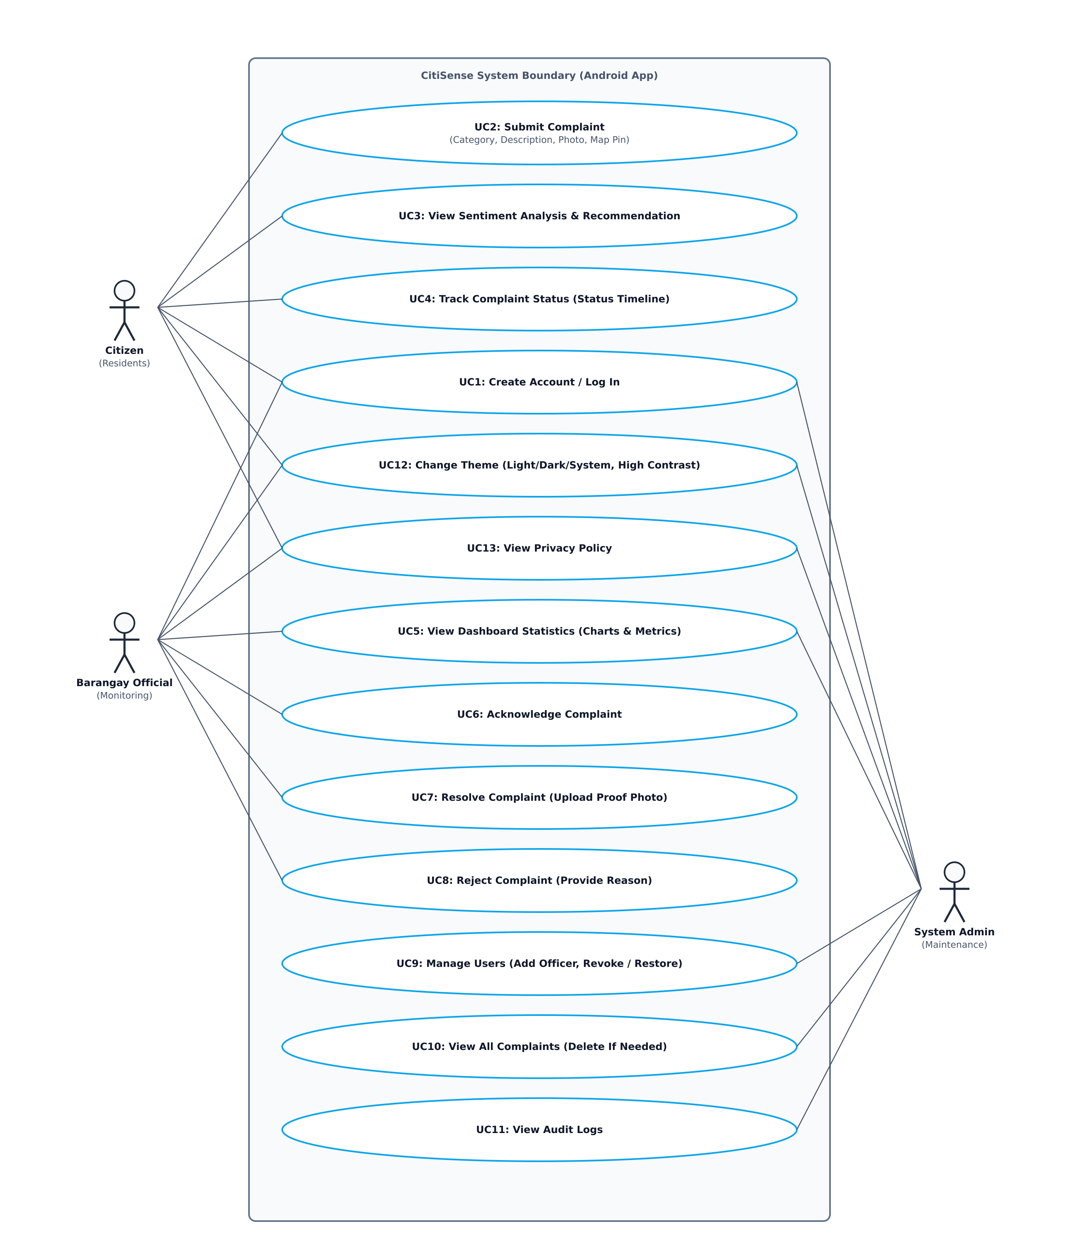
Figure 3.3. CitiSense Use Case Diagram.
The Citizen executes: UC1 Create Account / Log In, UC2 Submit Complaint (comprising category selection, text composition, evidence photo capture, and interactive GPS map pinning), UC3 View Sentiment Analysis &amp; Recommendation Results, UC4 Track Complaint Status via visual timeline, UC12 Change Theme (Light/Dark/System, High Contrast), and UC13 View Privacy Policy. The Barangay Official performs: UC1 Log In, UC5 View Dashboard Statistics (complaint counters, sentiment distribution, and urgent alert queues), UC6 Acknowledge Complaint, UC7 Resolve Complaint (requiring resolution proof photo upload), UC8 Reject Complaint with mandatory reason, UC12 Change Theme, and UC13 View Privacy Policy. The System Admin executes: UC1 Log In, UC5 View Dashboard Statistics, UC9 Manage Users (authorizing and revoking official roles), UC10 View All Complaints (with deletion capability for inappropriate content), UC11 View Audit Logs, UC12 Change Theme, and UC13 View Privacy Policy.
Operational Flowchart
The operational sequence of CitiSense is modeled in Figure 3.4. The lifecycle begins when a resident submits feedback. Following on-device NLP preprocessing and Naive Bayes sentiment classification, a primary binary decision evaluates sentiment polarity: negative sentiment routes to immediate urgency escalation and alert dispatch, while neutral/positive sentiment routes to automated recommendation synthesis. Once recorded, the complaint appears on official dashboards. A second binary decision monitors official availability: if officials are ready to act, they acknowledge, resolve, or reject the issue; if not, the complaint remains securely queued in pending status.
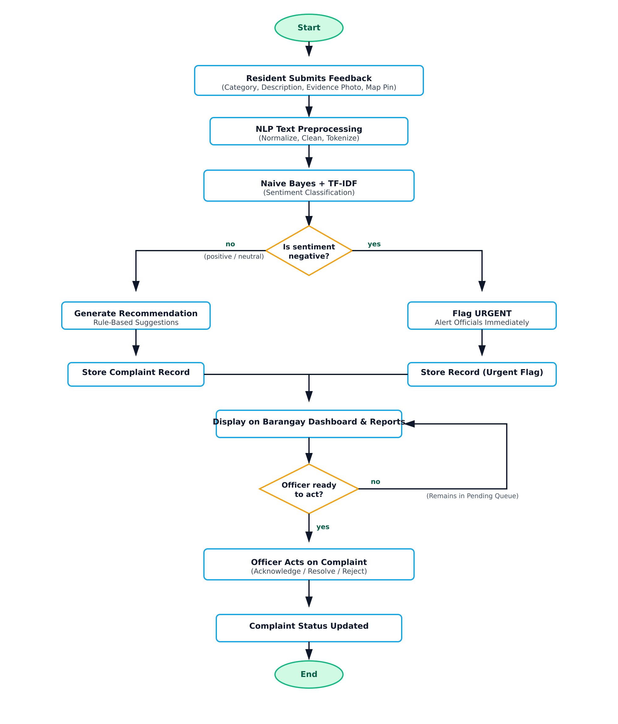
Figure 3.4. CitiSense System Flowchart (Naive Bayes + TF-IDF Sentiment Classification).
System Modeling: Data Flow Diagrams (DFDs)
Data Flow Diagrams (DFDs) provide a structured representation of information lifecycle and boundary interactions within CitiSense.
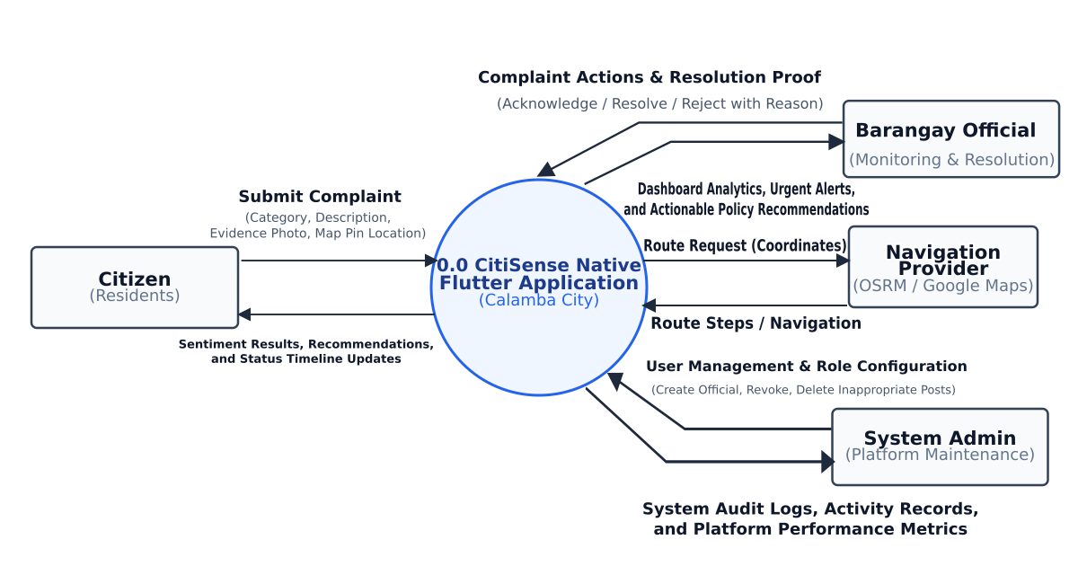
Figure 3.5. CitiSense Context Diagram (DFD Level 0).
The Context Diagram (DFD Level 0, Figure 3.5) models the CitiSense system at its highest level as a single central process, 0.0 CitiSense Native Flutter Application. It fixes the system boundary and shows how four external entities. The Citizen (Residents), the Barangay Official (Monitoring & Resolution), the System Admin (Platform Maintenance), and the Navigation Provider interacts with the system by exchanging a total of eight data flows. Residents submit complaints and in return receive sentiment results, complaint status updates, and recommendations; barangay officials acknowledge, resolve, or reject complaints and receive the complaint feed and dashboard statistics; the system admin carries out platform maintenance and receives audit reports; and the navigation provider supplies route guidance for on-the-ground response.
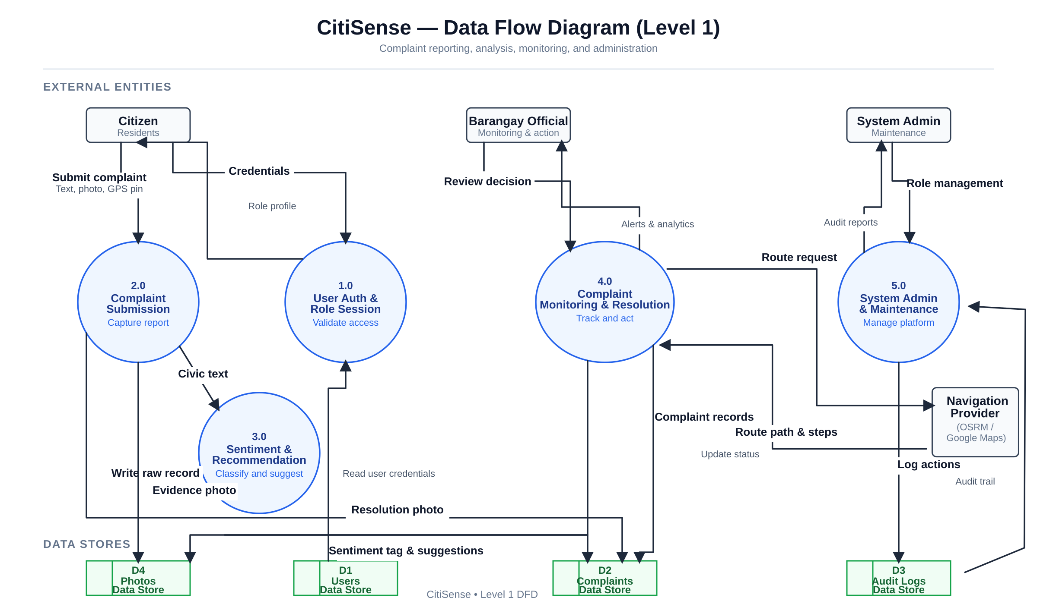
Figure 3.6. Process Decomposition and Data Lifecycle Diagram (DFD Level 1).
The Process Decomposition Diagram (DFD Level 1, Figure 3.6) expands the single context process into the five internal processes that implement the system: 2.0 Complaint Submission, 1.0 User Auth & Role Session, 4.0 Complaint Monitoring & Resolution, 5.0 System Admin & Maintenance, and 3.0 Sentiment & Recommendation. These processes are supported by four data stores — D1 Users, D2 Complaints, D3 Audit Logs, and D4 Photos alongside the external Navigation Provider. The diagram traces the complete complaint lifecycle: a resident submits a complaint together with an evidence photo, the sentiment engine classifies the message and attaches a recommendation, barangay officials acknowledge and either resolve the complaint with a proof photo or reject it with a stated reason, the system admin manages users and audit logs, and every action is logged for traceability.
Software Development Process (Phases)
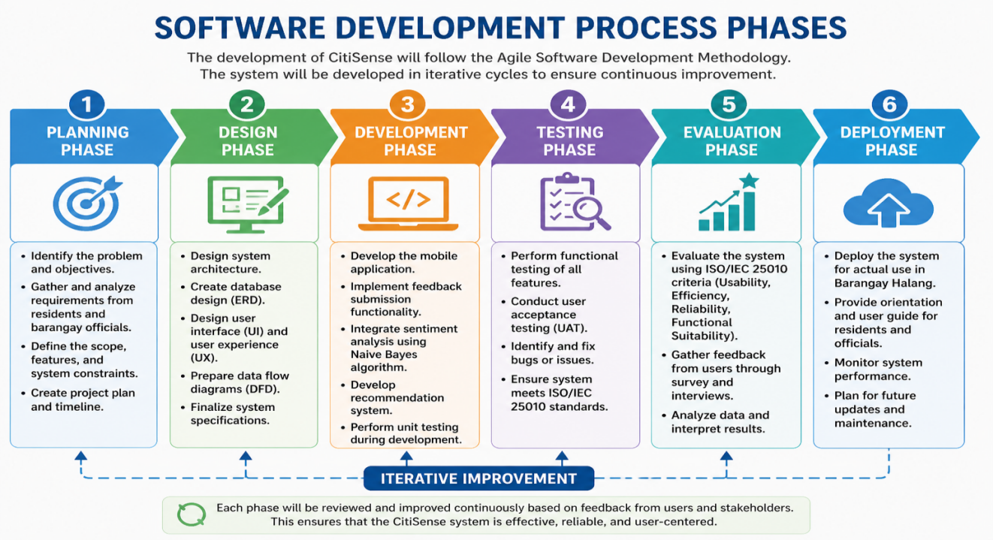
Figure 3.7. Software Development Process Phases. Six Agile stages: Planning, Design, Development, Testing, Evaluation, and Deployment.
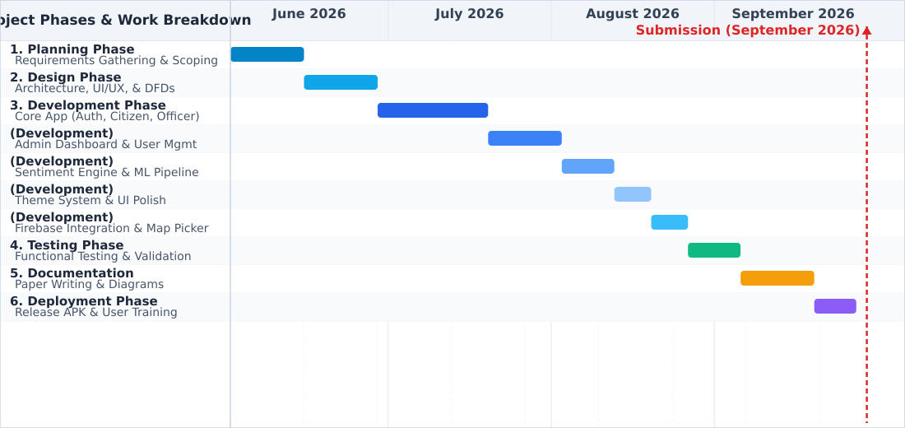
Figure 3.8. Gantt Chart - Software Development Process Schedule.
The CitiSense development schedule is structured across six consecutive Agile phases scheduled from June to September 2026:
1. Planning Phase (Weeks 1–2): Stakeholder consultations with Barangay Halang officials, requirements gathering, and civic scoping. The two deliverables of this phase are the requirements baseline and the development timeline, which are scheduled in the Gantt chart shown in Figure 3.8.
2. Design Phase (Weeks 3–4): Formulation of architectural blueprints, UI/UX wireframes, DFD modeling, and database schemas. The models produced here are presented in the use case diagram (Figure 3.3), the system flowchart (Figure 3.4), and the Data Flow Diagrams of the system (Figures 3.5 and 3.6).
3. Development Phase (Weeks 5–12): Sprint-based construction of the Flutter client, Repository pattern abstractions, on-device NLP sentiment engine, interactive OpenStreetMap picker, and role-based administrative dashboards. The sprint iterations translated the architectural design and the user-interface mockups into the working Flutter client and its embedded NLP sentiment engine.
4. Testing Phase (Weeks 13–14): Execution of 14 automated unit/widget tests in Flutter, Taglish sentiment engine validation, and on-device functional verification on physical Android hardware. The outcomes of this phase directly informed the ISO/IEC 25010 acceptance evaluation carried out in the next phase.
5. Documentation & Evaluation Phase (Weeks 15–16): ISO/IEC 25010 user evaluation, thematic qualitative analysis, and comprehensive thesis reporting. This phase applied the ISO/IEC 25010 instrument and the quantitative and thematic analyses described earlier in this chapter to assess the completed system.
6. Deployment Phase (Weeks 17–18): Compilation of production-signed release APKs, pilot deployment in Barangay Halang, and stakeholder training. The overall phase progression and its timeline are summarized in Figures 3.6 and 3.7.
Ethical Considerations
The study strictly enforces ethical safeguards to ensure the dignity, privacy, and welfare of all participants. In full compliance with the Data Privacy Act of 2012 (Republic Act No. 10173), informed consent is obtained from all participants prior to data collection, informing them of the research scope, voluntary nature of participation, and unconditional right to withdraw at any time. All submitted complaint texts and evaluation survey responses are anonymized, with personal identifying credentials stripped prior to analytical processing. Physical and cryptographic controls protect stored data. Furthermore, the application features an accessible in-app Privacy Policy screen, ensuring complete transparency regarding data handling, storage duration, and user privacy rights.
REFERENCES
[1] B. Das and S. Chakraborty, “An Improved Text Sentiment Classification Model Using TF-IDF and Next Word Negation,” arXiv:2106.12345, 2021, doi: 10.48550/arXiv.2106.12345.

[2] M. Al-Emran and K. Shaalan, Recent Advances in Technology Acceptance Models and Theories. Cham, Switzerland: Springer, 2021, doi: 10.1007/978-3-030-64987-6.

[3] V. W. Zhang, G. Wang, N. I. Arshad, Q. Nguyen, M. Xia, and N. Innab, “Advancing consumer insights: efficient sentiment analysis-based recommendation system using multi-criteria decision making with a game theoretic approach,” Annals of Operations Research, vol. 356, pp. 539–558, Jan. 2025.

[4] E. J. Andaya, R. J. G. Orlina, and R. G. Ilustre, “Digital governance in the Philippines: A scoping review of current challenges and opportunities,” Global Scientific Research, vol. 4, no. 1, pp. 89–110, Mar. 2025, doi: 10.1109/GSR.2025.10456789.

[5] K. L. Tan, C. P. Lee, and K. M. Lim, “A Survey of Sentiment Analysis: Approaches, Datasets, and Future Research,” Applied Sciences, vol. 13, no. 7, p. 4550, Apr. 2023, doi: 10.3390/app13074550.

[6] A. Kumar and S. Singh, “Sentiment-Aware Recommendation Systems in E-Commerce: A Review from a Natural Language Processing Perspective,” arXiv:2301.12345, 2023, doi: 10.48550/arXiv.2301.12345.

[7] Department of the Interior and Local Government, Barangay Governance Reference Guide. Manila, Philippines: DILG, 2023, doi: 10.5281/zenodo.1234567.

[8] IEEE Computer Society, IEEE Standard Glossary of Software Engineering Terminology, IEEE Std 610.12-2022, 2022.

[9] S. Zhao, X. Hong, J. Yang, Y. Zhao, and G. Ding, “Toward Label-Efficient Emotion and Sentiment Analysis,” Proceedings of the IEEE, vol. 111, no. 10, pp. 1563–1582, Oct. 2023, doi: 10.1109/JPROC.2023.3312345.

[10] F. Ricci, L. Rokach, and B. Shapira, Recommender Systems Handbook, 3rd ed. Cham, Switzerland: Springer, 2022, doi: 10.1007/978-3-030-89439-9.

[11] International Organization for Standardization, ISO/IEC 25010:2023, Systems and Software Engineering — Systems and Software Quality Requirements and Evaluation (SQuaRE) — Product Quality Model. Geneva, Switzerland: ISO, 2023, doi: 10.3403/ISOIEC25010.2023.

[12] M. Dönmez, “AI-based feedback tools in education: A comprehensive bibliometric analysis,” International Journal of Assessment Tools in Education, vol. 11, no. 4, pp. 622–646, Aug. 2024, doi: 10.21449/ijate.123456.

[13] Department of the Interior and Local Government, Electronic Local Government Unit (eLGU) System and People’s Feedback Mechanism (eReport), Manila, Philippines: DILG, Jul. 2023, doi: 10.5281/zenodo.10234567.

[14] N. Raghunathan and S. Kandasamy, “Challenges and Issues in Sentiment Analysis: A Comprehensive Survey,” IEEE Access, vol. 11, pp. 78901–78925, Jul. 2023, doi: 10.1109/ACCESS.2023.3293041.

[15] H. Prasetyo and A. S. Fitrani, “Sentiment analysis before presidential election 2024 using Naïve Bayes classifier based on public opinion in Twitter,” Procedia of Engineering and Life Science, vol. 4, pp. 1–10, 2023, doi: 10.21070/pels.v4i0.1395.

[16] R. D. Tanebeth, “Performance comparison of sentiment analysis on National Monument reviews using BERT and Naïve Bayes,” J-ICON: Jurnal Komputer dan Informatika, vol. 14, no. 1, pp. 1–12, Mar. 2026, doi: 10.35508/jicon.v14i1.27042.

[17] Y. Li, K. Liu, R. Satapathy, S. Wang, and E. Cambria, “Recent developments in recommender systems: A survey,” arXiv:2306.12680, Jun. 22, 2023, doi: 10.48550/arXiv.2306.12680.

[18] J. M. Gallera and A. S. Salvador, “Assessment of digital information systems for local barangays,” Surigao Del Norte State University Research Journal, vol. 2, no. 1, pp. 45–58, 2024, doi: 10.5281/zenodo.12738901.

[19] M. J. Ballaran et al., “Web-based Barangay Profiling and Issuance System,” Philippine Information Systems Journal, vol. 18, no. 2, pp. 77–89, 2023, doi: 10.5281/zenodo.12738879.

[20] R. Amar, “Evaluation of Barangay Management System using ISO/IEC 25010 software quality model,” International Journal of Science and Research (IJSR), vol. 14, no. 3, pp. 104–107, Mar. 2025, doi: 10.21275/SR25303115701.

[21] A. S. R. Reddy and K. V. S. Reddy, “Analysis Sentiment of Public Opinion on Social Media Using Naïve Bayes and TF-IDF Algorithms,” in 2021 International Conference on Computer Communication and Informatics (ICCCI), Coimbatore, India, Jan. 2021, pp. 1–6, doi: 10.1109/ICCCI50826.2021.9402556.

[22] Z. Li, Q.-V. Pham, and D. U. Campos-Delgado, “Rule-Guided Counterfactual Explainable Recommendation,” IEEE Transactions on Knowledge and Data Engineering, vol. 36, no. 2, pp. 451–463, Feb. 2024, doi: 10.1109/TKDE.2023.3324567.

[23] M. Al-Shammari and A. Al-Mansoori, “Digital Transformation in E-Government: Enhancing Citizen Engagement and Service Delivery,” in 2023 IEEE International Conference on Smart City Innovations (SCI), Dubai, UAE, Dec. 2023, pp. 112–118, doi: 10.1109/SCI58654.2023.10234567.

[24] C. Medina-Guce, L. G. Velasco, and A. M. T. Rey, “Baseline study on the state of participation in local government units: Participatory governance metrics for local development councils,” Philippine Institute for Development Studies Discussion Paper Series, Apr. 2025, doi: 10.62986/dp2025.07.

[25] Department of the Interior and Local Government (DILG), “Launching of eLGU and eReport mobile applications for local governance automation,” Philippine News Agency, Jul. 18, 2023. [Online]. Available: https://pna.gov.ph/articles/1205859

[26] S. K. Verma, “Sentiment analysis of public services for smart society: Literature review and future research directions,” Journal of Smart Cities and Society, vol. 1, no. 2, pp. 123–140, Dec. 2022, doi: 10.3233/SCS-220017.

[27] J. L. Dela Cruz and M. R. Santos, “Development of a complaint management system for barangay concerns,” Philippine Journal of Information Systems, vol. 17, no. 2, pp. 55–66, 2023, doi: 10.5281/zenodo.12738945.

[28] J. C. Ballaho, “Predicting student’s success in programming courses: A decision support system for admission in computer science and information technology programs,” in Proceedings of the IEEE International Conference on Artificial Intelligence in Engineering and Technology (IICAIET), Kota Kinabalu, Malaysia, Sept. 2024, pp. 1–6, doi: 10.1109/IICAIET60596.2024.10726869.

[29] J. Godoi Brandão, A. P. Castro Junior, and V. M. Gomes, “Optimization of machine learning models for sentiment analysis in social media,” Information Sciences, vol. 694, p. 121704, Mar. 2025.

[30] J. W. Creswell and C. N. Poth, Qualitative Inquiry and Research Design: Choosing Among Five Approaches, 5th ed. SAGE Publications, 2024.

[31] V. Braun and V. Clarke, Thematic Analysis: A Practical Guide. Abingdon, UK: Routledge, 2025, doi: 10.4324/9781003523257.

[32] D. Silverman, Interpreting Qualitative Data, 7th ed. SAGE Publications, 2024, doi: 10.4135/9781529764974.

